**PRATIKSHA P**

9035669350 | [kshirsagarpratiksha1820@gmail.com](mailto:sanjanasheelvant0203@gmail.com)

 https://[www.linkedin.com/in/](http://www.linkedin.com/in/sanjana-shivakumar-sheelvant-1a6a7424b)pratiksha-kshirsagar-96579a2b1

**OBJECTIVE**

To leverage my skills and knowledge effectively in a dynamic organization that fosters growth and offers opportunities for learning. Seeking a role where I can contribute positively, learn from experienced professionals, and make meaningful contributions to the organization’s objectives.

**EDUCATION**

2021-2024

2019-2021

2018-2019



Basavakalyan Engineering College, Basavakalyan

Bachelor Of Engineering

Computer Science and Engineering

Pursuing

Alva’s Pre-University College, Moodubidire

Science 90.33%

Florence English Highschool, Bangalore

NCERT 90.88%

HTML CSS

Java Script

CSS Bootstrap

Python

Basics of Java

Basics of Cloud computing

Basics of DataBase Management System

Git and GitHub

Angular JS

Adaptability &Flexibility

Leadership potential Time Management

Attention to details

**PROJECT**

**Spotify Frontend Clone - Based on HTML, CSS, JS**

Developed a responsive Spotify clone with HTML, CSS, and JavaScript, demonstrating adaptability to

various devices and screen sizes, and showcasing expertise in front-end web development and user

interface design. ([https:/github.com/Pratiksha18Kshirsagar/SPOTIFY-CLONE](https://github.com/Pratiksha18Kshirsagar/SPOTIFY-CLONE))

**Task Management System - Based on DBMS**

Created a task management system using XAMPP for the backend database management, coupled with

Bootstrap for front-end design. Demonstrated proficiency in database management and responsive web

development, providing a seamless user experience across devices.

**Netflix Frontend Clone - Based on HTML, CSS**

Developed a responsive Netflix clone with HTML and CSS demonstrating adaptability to

various devices and screen sizes, and showcasing expertise in front-end web development and user

interface design.

(<https://github.com/Pratiksha18Kshirsagar/Sigma-web-dev/tree/main/Projects!!/Netflix-using-html-css>)

Drawing and Art

Participating in a Social activity

Volunteer In many of the events conducted in our college

**LANGUAGE**

English Kannada

Hindi

Marathi

**PERSONAL DEATAILS**

Date of Birth : 18/11/2003 Nationality : India Gender : Female

Mother Name : Pradeep Kshirsagar

Mother Name : Smitha P

I hereby Declare that the above submitted information is true to the best of my knowledge

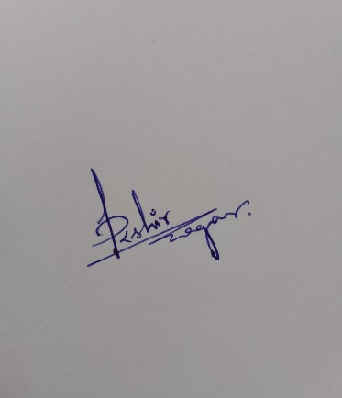

PRATIKSHA P